Interim Report - "How fast do Molecular Clouds grow?"

Kevin Ning

# Abstract

*+White space for cover sheet*

# Background

The interstellar medium (ISM) is a collection of gaseous, solid particles and cosmic rays that exist throughout space. The gaseous portion takes up of the mass in the ISM meanwhile the solid particles known as dust take the remaining 1%. The composition of the gases consists of hydrogen and helium with the remaining being heavier elements . The density and chemical composition of the ISM tends to vary however, but can be broadly split into five categories: hot ionised, warm ionised, warm atomic, cold atomic and cold molecular mediums. The cold molecular medium otherwise known as molecular clouds is of particular importance.

Molecular clouds are well known for being the main site of star formation. The cold nature of the molecular cloud results in a minimal amount of thermal pressure, which decreases the requirements for gravitational collapse. The temperatures required for this to occur is in the range of K. This is substantially lower than the cold atomic medium which has temperatures in the ranges of K. While this may seem to suggest the molecules of the cloud possess a efficient means of cooling, this is not necessarily true. The primary constituent of the molecular cloud, H2, has an relatively high energy requirement for its first excited state of J K] . Unsurprisingly, the emissions from H2 within the molecular cloud is negligible. On the other hand, CO is another molecule commonly found in the molecular clouds with a much lower energy requirement of J [K] for the emission line. Due to the high density of H2, CO can be easily excited through collisions with H2 . This gives a method of tracing the density of H2 in the cloud using the observed intensity of CO. Cooling through CO radiation is significant but is not required to reach range of K. Simulations using cooling from C+ (C II) fine-structure lines with sufficient dust extinction also show they can reach similar temperatures. In fact, simulations also show the presence of molecular gas has little effect on the ability to form stars and appear to be a by-product of the conditions required for star formation .

The formation of hydrogen molecules heavily depends on dust. As collisions with gaseous hydrogen atoms usually result in both being repelled, actual rate of reaction alone is very low. The dust grains can act as a catalyst however and enables hydrogen atoms to attach onto the surface to rid itself of its excess energy . This prevents the rebound of hydrogen atoms and also chance of contact if the hydrogen atoms bind using van der Waal interactions. Dust also shields the resulting hydrogen molecule from UV rays to prevent dissociation. Any energy absorbed from the UV ray is then radiated away aiding in cooling.

*-Add more on [Observations] : Atomic lines / radiative processes(Einstein coefficients) / line broadening?*

*STAGE 2: Gravitational collapse (Jeans mass/length) -> turbulence and magnetic field (+ observations and magnetic braking)*

If a isothermal molecular cloud of uniform density is sufficiently large enough, it will become gravitationally unstable and collapse. For a spherical model of the cloud this radius is known as the Jean's length . The mass associated with this length is known as the Jean's mass given as:

|  |  |  |
| --- | --- | --- |
| *Probably don't need this here* |  | [1] |

where is the mass density and is the sound speed which has dependence. In the case where the cloud has no outward support mechanism, the time it takes to collapse is given by the free-fall time:

|  |  |  |
| --- | --- | --- |
| *Probably don't need this here* |  | [2] |

which represents the minimum timescale a cloud can collapse in . However, the actual percentage of the cloud that is converted into stars within a free-fall time is much lower than one. It is found that only cloud is converted into stars for a single free-fall time.

Observations of the ISM show large amounts of polarisation in the starlight received. This effect has been accredited to the dust aligning on a large scale to polarise the light for a particular axis. In order to produce such a effect there must be a equally large magnetic field which can be measured from the polarised light using the Zeeman effect . The compression of the ISM into molecular clouds and later into pre-stellar cores also causes the magnetic field lines to compress as well. This increases the magnetic field strength which also increases magnetic pressure that opposes gravitational collapse. The magnetic field also aids in gravitational collapse by removing angular momentum from pre-stellar cores through magnetic braking. This reduces the angular speed of the outer parts of the envelope, allowing it to collapse inwards towards the core.

Observations of a molecular cloud's spectral lines usually possesses some degree of additional line broadening caused by Doppler shifts. A significant amount of this can be explained by the thermal velocity dispersion of the gas in the cloud however there is still a large amount that cannot be explained other broadening methods. This non-thermal velocity dispersion is caused by turbulence . Turbulence can arise from a multiple sources such as stellar winds, protostellar outflows or supernovas . Each one of these sources creates some degree of shock front. These shock fronts sweep up material and compress the cloud, producing regions of decreased and increased density. If the shock is sufficiently large enough, the regions of decreased density will lose their gravitational support and disperse. On the flip side, the regions of increased density may become gravitationally unstable and begin to collapse .

Turbulence has a been attributed to variety of effects such as creating molecular cloud cores through compressive motions and fragmentation of the cloud.

*STAGE 3: Cores + accretion ->* ***Stellar systems (Classes)*** *+ observations + high mass stars* ***(+fragmentation & multiplicity****)*

When the cloud becomes gravitationally unstable and starts collapsing, multiple processes occur in the cloud that prevents and assists collapse. Initially, the gravitational energy gained from the collapsing gas is radiated away keeping the pre-stellar core isothermal. The pre-stellar core steadily accretes mass into its centre, forming a protostar. The excess angular momentum from the infalling material also causes the formation of a disk surrounding the protostar. However the accumulating dust increases the opacity towards the centre of the pre-stellar core, reducing the ability to radiate away energy. This results in a steady decrease in luminosity with a minor temperature increase known as the Hayashi track. Eventually the centre of the protostar becomes too opaque to radiate effectively causing a rapid increase in temperature. This density required to reach this point is around gcm-3 .This process will raise the temperature until around K where the dust grain evaporation occurs and H2 dissociation begins. As the dust gets vaporised, opacity decreases and H- becomes the primary source of opacity . When the dissociation of H2 ends, the star then starts hydrogen burning. While the formation process for low mass stars is reasonably well understood, the formation of extreme cases of high mass stars and brown dwarfs are much less known.

Using the same assumptions as with low mass stars, it can be calculated that there is a maximum mass limit due radiation pressure. This is limit can be calculated to be in the range of M☉ indicating that the assumptions made are incorrect or that there are different mechanisms for high mass star formation(2). One assumption made is that accretion of material is spherically symmetric. It is already known that infalling material tends to form a disc round a protostar due to angular momentum. Consequently a large amount of accretion would occur from the disc and the amount of radiation pressure felt by the accreting material will be drastically lower. This alone cannot enable the formation of high mass stars, as this requires the majority of the material to be held within the disc before the protostar starts emitting large amounts of radiation pressure. However gravitational torque will prevent the disc mass exceeding the core mass which limits the effectiveness for this method of accretion (10). There is also a assumption that the dust grain sizes and abundances are constant which may not be the case (11).

There are other theories for high mass star formation. The "competitive accretion" model suggests that stars at the centre of a stellar cluster will naturally accrete more mass as a result of gravitational focusing. As a result it is possible for such a star to rapidly accrete mass into a massive accretion disk to overcome more radiation pressure (12). This model is limited to stellar clusters and suggests lone high mass star formation cannot occur. Another suggested formation method is through collisions of lower mass stars. Accretion of material in a stellar cluster will increase the mass and gravitational attraction of the stars within it. This will subsequently decrease the size of the stellar cluster and increase the chance of collisions between stars (10). Eventually the collisions will dominate over accretion for mass gain, allowing this method to completely bypass the problems associated with radiation pressure. This method is also limited to stellar clusters and also suggests a decrease in number of the intermediate mass stars ( M☉) used in the collisions (10).

# Project Outline

The purpose of this project is to investigate the differences in molecular cloud growth between accretion from the ISM and collisions of clouds. This will be done by writing code to produce a computer simulation of a GMC for a time period. The result of the computer simulation will then be analysed to explain the effects that collisions and accretion have on star formation in the GMC.

# Project Design

*Physics used (Bondi-Hoyle equation, assumptions made, equations/topics used for analysis?), outline code features (Integration methods, Energy calculation, timestep control, box boundary conditions, collision modelling, particle bookkeeping +exploding particles, central z-axis potential(?))*

The simulation for the GMC consists of a large number of particles each mimicking a spherical molecular cloud. Each particle will be given a mass of M☉ with a random velocity vector. The velocity vectors will be scaled up or down to create a Gaussian distribution with a standard deviation of kms-1. The densities of the clouds will be kept constant but result in a average ISM number density of 10 cm-3. The size of each cloud will be calculated from its mass and density. All of this occurs in a box with wrapping along the x and y axis with dimensions of approximately 100 parsecs for both. The z axis will not have a distance limit but instead have a gravitational potential to draw particles into the centre of the z axis.

When the simulation begins, the gravitational accelerations of every particle is calculated at each timestep and the next timesteps' positions and velocities are calculated numerically and this process repeats. The gravitational acceleration for particle in the x-direction is calculated using

|  |  |  |
| --- | --- | --- |
|  |  | [1] |

where is the distance between the two particles and is the difference in x-coordinates. Acceleration in and coordinates can be found replacing with their respective differences. The softening factor is used to more accurately model the effect of close approaches between clouds. This factor corresponds the radius of the molecular cloud and will change as the particles gain mass.

The numerical integration method used in this project is the 'Velocity Verlet' method. This method makes a assumption that accelerations only depend on position which is correct for this project. Due to the large accelerations produced from close approaches between particles, a very small timestep is required to retain accuracy. However consistently small timestep will result in a very slow simulation. Subsequently, a timestep control method is required to maximise efficiency. This has the form:

|  |  |  |
| --- | --- | --- |
|  |  | [1] |

where is a tolerance parameter. The timestep is calculated across all particles and the minimum timestep is used. Currently no ideal tolerance parameter has been found.

In order to observe the stability of the simulation, the kinetic and gravitational energies of the particles are also calculated alongside gravitational accelerations.

# Preliminary Results

The current structure of the simulation program is split into two distinct parts; the numerical integration loop and gravitational acceleration function. The gravitational acceleration function acquires the distance between two particles in each component. Another calculation of component distance is performed for the and axis to account for box wrapping. This second calculation uses the distance going through the edges of the bounded box. The lower of the two distances is then used to calculate the acceleration in each direction for both particles selected. The process is repeated in two nested loops until all particle combinations have been completed. Within the same loop, a calculation of the gravitational potential energy and timestep is also preformed, reusing the distance calculations from gravitational acceleration. Outside of the two nested loops, another loop is preformed to calculate the kinetic and total energy of each particle. The dimensions of this loop are different from the nested loops so it is not possible to insert the remaining energy calculations within the nested loops.

The second part of the program is the Velocity Verlet integration. This firstly calculates the position of the next timestep using the current velocity and acceleration for all particles. If the resulting position exceeds the boundaries of the box, it is teleported to the opposite side of the box. The current acceleration value is then temporarily saved into a separate array. The gravitational acceleration function is then called, outputting the size of the next timestep and the updated accelerations. Then the velocities of the particles are then updated using both the previous and updated accelerations. The calculated timestep is then added to the total time and this process loops until the maximum time is exceeded.

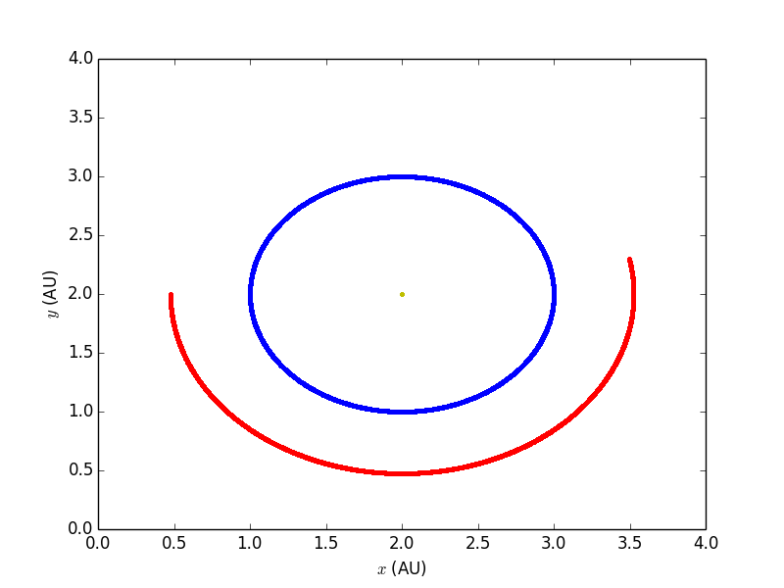

**Figure.1** The orbits of the Earth is shown in blue with the orbit of Mars in red. The yellow centre dot is the sun. The sun while appears stationary in this figure, does move very slightly in response to the planets. This simulation had a maximum time of one year.

The simulation's numerical integrator was tested using an Sun, Earth and Mars system. As shown in figure 1, the orbits of the planets remain stable. It can be seen the orbit of the Earth starts and ends on approximately the same position for a year-long orbit.

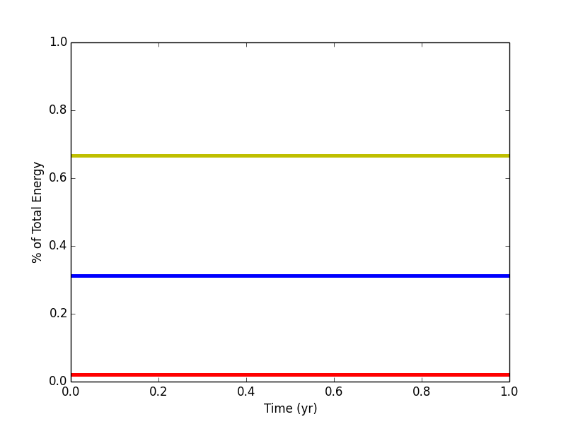

**Figure.2** The energies of the Sun (yellow), Earth (blue) and Mars (red). No variance can be seen.

The corresponding energies for the three particle system also show no variance further illustrating a stable orbit. The maximum timestep size allowed in this simulation was th of a year. However the tolerance and softening factor were lowered in this simulation to forcefully produce a lower timestep by the timestep control equation. The actual number of iterations ran for this simulation was 2142. This verified a basic functionality for the timestep control in the simulation.

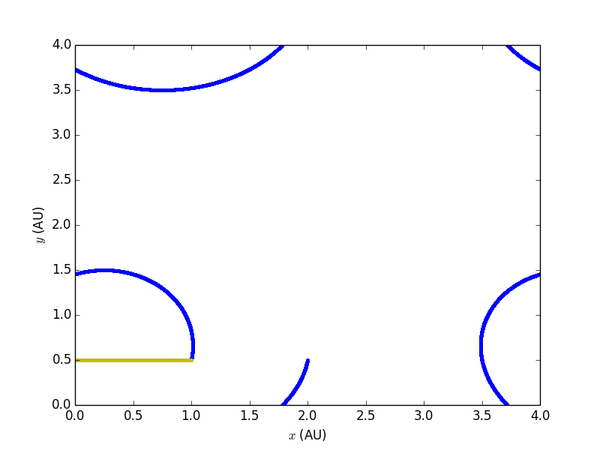

**Figure.3** Test for to verify box wrapping functionality. The Sun and Earth system was placed at and AU respectively. Both particles were given a velocity of AU/yr in the -direction. Mars has been removed from the simulation for clarity.

The box wrapping were also tested by placing the Sun and Earth close the edge of the box. A additional velocity vector of AU/yr was also added to both particles to ensure boundary checks were occurring at the correct times. It can be seen in Figure.3 that the Earth retains its distance of AU from the Sun after one year as is expected without box wrapping.

# Future Objectives

While currently most features are in place to model the motions of particles in a wrapped box, both the initial conditions of particles and main gain methods need to be implemented.

The accretion method that will be used in this project is the Bondi-Hoyle accretion model. This model assumes that the accreting mass can be approximated as a point mass that moves through a infinite stationary background ISM. As it does so, sufficiently close background mass is pulled towards the point mass into a accretion column wake behind the direction of motion which is then accreted. The radius that determines whether the background material is accreted is referred to as the Hoyle-Lyttleton radius and takes the form of:

|  |  |  |
| --- | --- | --- |
|  |  | [1] |

where refers to the relative velocity of the gas to the point mass. The corresponding accretion rate for a column wake is then:

|  |  |  |
| --- | --- | --- |
|  |  | [1] |
|  |  |  |

refers to density of the background ISM and is a accretion column parameter. is expected to be in the range of - . This model also assumes the background has no self-gravity and the relative velocity of the gas is supersonic. Given the initial conditions of the molecular clouds, this is a reasonable assumption. This model does ignore radiative feedback in the wake but this effect is negligible in highly supersonic flows .

The main assumption that may give inaccurate results is the assumption of a point mass. Molecular clouds, while much denser than the background ISM are still very diffuse. It is possible in some cases the Hoyle-Lyttleton radius may be lower than the actual size of the cloud. For this project, the larger of the two radii will be used to calculate accretion for any given timestep.

Many of the details of collision model have not been fully decided upon, so this section will only give a brief overview of the process and problems. For the simulation, a collision will be classified as occurring when the distance between two particles is below some threshold. This threshold has not been decided upon but it is likely to be directly related to the softening factor and hence size of the molecular clouds. Collisions in this project will be assumed to be perfectly elastic. When a collision occurs between two particles both particles will recombine into a single particle. This results in a 'book-keeping' problem where particles are removed from the simulation randomly. It is likely that the arrays used for storing particle data will have to be reorganised during the collision to prevent calculations of empty data values.

In order to prevent collisions from removing nearly all particles in the simulation a method or generating new particles must be present. This takes the form of supernovas. After a particle accumulates enough mass, the particle will begin a countdown of a few million years. At the end of the countdown, the particle will be forced to split into multiple other smaller mass particles . This simulates the process of high mass star formation and star lifetime. Like with collisions, this also requires a method of modifying the particle data to accommodate the new particles.

# References

x

|  |  |
| --- | --- |
| 1. | Ferriere K. The Interstellar Enviroment of our Galaxy. Reviews of Mordern Physics. 2001 June; 73(4). |
| 2. | D.Ward-Thompson APW. An Introduction to Star Formation. 1st ed. Cambridge: Cambridge University Press; 2011. |
| 3. | S.C.O.Glover MMM. SIMULATING THE FORMATION OF MOLECULAR CLOUDS. I. SLOW FORMATION BY GRAVITATIONAL COLLAPSE FROM STATIC INITIAL CONDITIONS. The Astrophysical Journal Supplement Series. 2007 April; 169(2). |
| 4. | S.C.O.Glover PCC. Is molecular gas necessary for star formation? Monthly Notices of the Royal Astronomical Society. 2012 March; 421(9). |
| 5. | N.J.Evans. Physical Conditions in Regions of Star Formation. Annual Reviews. 1999 September; 37. |
| 6. | M.R.Krumholz JCT. Slow Star Formation in Dense Gas: Evidence and Implications. The Astrophysical Journal. 2007 April; 654(1). |
| 7. | J.Ballesteros-Paredes RSKMMLEVS. Molecular Cloud Turbulence and Star Formation. In B. Reipurth DJKK, editor. Protostars and Planets V. Tucson: University of Arizona Press; 2006. p. 63–80. |
| 8. | R.S.Klessen PCCSCOG. Formation of Stellar Clusters and the Importance of Thermodynamics for Fragmentation. Proceedings of the Internional Astronomical Union. 2007 September; 3(246). |
| 9. | C.Low DLB. The Minimum Jeans Mass or When Fragmentation Must Stop. Monthly Notices of the Royal Astronomical Society. 1976 August; 176(2). |
| 10. | I.A.Bonnel MRBHZ. On the formation of massive stars. Monthly Notices of the Royal Astronomical Society. 1998 July; 298(1). |
| 11. | M.G.Wolfire JPC. Conditions for the Formation of Massive Stars. The Astrophysical Journal. 1987 August; 319(1). |
| 12. | I.A.Bonnel MRBCJCJEP. Accretion and the stellar mass spectrum in small clusters. Monthly Notices of the Royal Astronomical Society. 1997 February; 285(1). |
| 13. | Hoyle.F LRA. The Effect of Interstellar Matter on Climatic Variation. Proceedings of the Cambridge Philosophical Society. 1939 April; 35(3). |
| 14. | Bondi.H HF. On the mechanism of accretion by stars. Monthly Notices of the Royal Astronomical Society. 1944 October; 104(5). |
| 15. | E. Shima TMHTKS. Hydrodynamic calculations of axisymmetric accretion flow. New Astronomy Reviews. 1985 June; 217(2). |

x